

A PROJECT REPORT

ON

ONLINE CLINIC MANAGEMENT SYSTEM

DONE BY

Nikita Nandakishor Naik

(EBEON0920320073)

Under the Guidance of,

**Mr. V JAYANTH**

**Technical Trainer**

**NASSCOM PROJECT**

**­**

**ARISE**

**ONCAMPUS**

**SOFTWARE DEVELOPER TRAINEE**

Tambaram, Chennai-600045 (Tamil Nadu)­­

2020

**ABSTRACT**

Online Clinic Management System provides the benefits of streamlined operations, enhanced administration & control, superior patient care, strict cost control and improved profitability. Clinic is powerful, flexible, and easy to use and is designed and developed to deliver real conceivable benefits to clinics. More importantly it is backed by reliable and dependable support. The project ‘Online Clinic Management System’ is based on the database, object oriented and networking techniques. As there are many areas where we keep the records in database for which we are using MY SQL software which is one of the best and the easiest software to keep our information. This project uses JAVA as the front-end software which is an Object Oriented Programming and has connectivity with MY SQL. Online Clinic Management System is custom built to meet the specific requirement of the mid and large size clinics across the globe. All the required modules and features have been particularly built to just fit in to your requirement. This package has been widely accepted by the clients in India and overseas. Not stopping only to this but they are highly satisfied and appreciating. Entire application is web based and built on 3 tier architecture using the latest technologies. The sound database of the application makes it more users friendly and expandable. The package is highly customizable and can be modified as per the needs and requirements of our clients. Prolonged study of the functionalities of the hospital and its specific requirement has given it a wonderful shape both technically and usability wise. It covers all the required modules right from Patient Registration,­­ Medicine details, Doctor, Admin, Store, Patient appointment, bill payment, record modification etc.

**TABLE OF CONTENT**

**S. TITLE PAGE NO**

**1. INTRODUCTION TO THE STUDY**

* Introduction 5
* Definition of the Problem 5
* Drawbacks Of Current Manual- System 5
* Established the need of new System 6
* Proposed system 6
* Need 7

**2. AIMS & OBJECTIVES OF THE STUDY**

* Objective 8
* Aims 8

**3. LITRATURE REVIEW** 9

**4. RESEARCH METHOD** 11

**5. SYSTEM DESIGN**

* System Overview 12
* Use Case 13

* ER Diagram 13
* Data Flow Diagram 14

**6. SYSTEM ANALYSIS**

* System Study 17
* Advantages 18
* Outcome 18

**7. CONCLUSION** 19

**8. REFERENCES** 20

**9. SNAPSHOTS** 21

**CHAPTER – 1**

**INTRODUCTION TO THE STUDY**

* 1. **Introduction:**

Clinic is a place where the doctors treat their patients for the disease that they are suffering from. Sometimes taking a doctor’s appointment on the particular day involves a tedious task. There will be many reasons through which the appointment cannot be getten by the patients. What if the appointments can be got through the online mode? Yes it is possible. The Online clinic Appointment System will fulfill this task. This application will allow the patients to take the appointment and also to track the patient details without any difficulty. The user needs to open this website and navigate to “Book an appointment” to take the appointments. This application will automatically provide new appointments to the people.

* 1. **DEFINITION OF PROBLEM:**

The main purpose of this project is to link and bring all major private medical clinics of the city (of my country) to a single platform. So that patients can easily get access to the doctor’s profile and make online appointments. The second purpose is to create an online medical history database so that doctors and patients can freely exchange patients’ medical history information much easier, faster, and safe

* 1. **DRAWBACKS OF CURRENT MANUAL- SYSTEM**

1.The current manual system has a lot of paper work and it does not deal with old and

new car purchase and sale.

2. To maintain the records of sale and service manually, is a Time-consuming job.

3. With the increase in database, it will become a massive job to maintain the database.

4. Requires large quantities of file cabinets, which are huge and require quite a bit of

space in the office, which can be used for storing records of previous details.

5. The retrieval of records of previously registered patients will be a tedious job.

6. Lack of security for the records, anyone disarrange the records of your system.

7. If someone want to check the details of the available doctors the previous system

does not provide any necessary detail of this type.

* 1. **ESTABLISH THE NEED OF NEW SYSTEM**

1.Problem of Reliability: Current system is not reliable. It seems to vary in quality

from one month to the, next. Sometimes it gives good output, but some times the

output is worst.

2. Problem of Accuracy: There are too many mistakes in reports.

3. Problem of timeliness: In the current system the reports and output produced is

mostly late and in most of the cases it is useless because it is not on time.

4. Problem of Validity: The output and reports mostly contains misleading information.

The customer’s information is sometimes not valid.

5. Problem of Economy: The current system is very costly. We have to spend lots of

money to keep the system up and going, but still not get the desired results.

6. Problem of Capacity: The current system is suffering from problem of capacity also.

The staff for organization is very less and the workload is too much. Few peoples

cannot handle all the work.

**1.6 PROPOSED SYSTEM**

**l. Employee Details:** The new proposed system stores and maintains all the employees

details.

**2. Calculations:** The new proposed system calculates salary and income tax

automatically and it is very fast and accurate.

**3. Registers:** There is no need of keeping and maintaining salary and employee register

manually. It remembers each and every record and we can get any report related to

employee and salary at any time.

**4. Speed:** The new proposed system is very fast with 100% accuracy and saves time.

**5. Manpower:** The new proposed system needs less manpower. Less people can do the

large work.

**6. Efficiency:** The new proposed systems complete the work of many salesperson in

less time.

**7. Past details:** The new proposed system contains the details of every past doctor and

patients for future assistance.

**8. Reduces redundancy:** The most important benefit of this system is that it reduces

the redundancy of data within the data.

**9. Work load:** Reduces the work load of the data store by helping in easy updates of

the products and providing them with the necessary details together with financial

transactions management.

**10. Easy statements:** Month-end and day-end statement easily taken out without

getting headaches on browsing through the day end statements.

**1.7 NEED:**

I have designed the given proposed system in the JSP to automate the process of day to

day activities of hospital like Admission of New Patient, Book an appointment of patients, Assign a Doctor, and etc., online facilities to the multiple

users etc.

The complete set of rules & procedures related to Clinic’s day to day activities and

generating report is called **“ONLINE CLINIC MANAGEMENT SYSTEM”.** My project

gives a brief idea regarding automated Clinic activities.

The following steps that give the detailed information of the need of proposed system are:

Performance: During past several decades, the hospital management system is supposed

to maintain manual handling of all the clinic daily activities. The manual handling of

the record is time consuming and highly prone to error. To improve the performance of

the hospital management system, the computerized hospital management system is to be

undertaken. The computerized hospital project is fully computerized and user friendly

even that any of the hospital’s members can see the patient’s report and the doctor’s

report.

Efficiency: The basic need of the project is efficiency. The project should be efficient so

that whenever a new patient is admitted, and automatically a bed is assigned and also a

doctor is assigned to the patient according to the patient’s disease. And book their an appointment.

Control: The complete control of the project is under the hands of authorized person who

has the password to access this project and illegal access is not supposed to deal with. All

the control is under the administrator and the other members have the rights to just see

the records not to change any transaction or entry.

Security: Security is the main criteria for the proposed system. Since illegal access may

corrupt the database and it will affect not only the hospital but also it also affects the

patient’s life. So security has to be given in this project.

**CHAPTER – 2**

**AIMS & OBJECTIVES OF THE STUDY**

**2.1 OBJECTIVE:**

The main objective of the thesis is to provide quality medical care to the patients by bringing all medical practitioners of the city to a single platform so that everybody can easily access them and make appointments. The second objective is to replace the current manual file keeping system with an online medical patient database system.

**2.2 AIM:**

The aim of this project is to create a platform where patients and doctors can access /interact efficiently with each other and provide ease and comfort to the patients. It also aims to resolve the problems that patients have to face while taking appointments and keeping medical files. Patients can choose a medical practitioner based on their professional profile and other patient’s reviews. While doctors can access and update a patient’s medical record after every checkup. Following features will be added in the future: • Online follow up with doctors (specially for distant patients)

• Linking laboratory and pharmacy so that medical store administrator can view suggested prescription and laboratory can view clinical tests recommended by the doctor. This feature aims to eliminate paper-based prescriptions.

**CHAPTER – 3**

**LITERATURE REVIEW**

1. **Mr. Doc: A Doctor Appointment Application System**

Author: Shafaq Malik, Nargis Bibi, Sehrish Khan, Razia Sultana, Sadaf Abdul Rauf

If anybody is ill and wants to visit a doctor for checkup, he or she needs to visit the hospital and waits until the doctor is available. The patient also waits in a queue while getting appointment. If the doctor cancels the appointment for some emergency reasons then the patient is not able to know about the cancelation of the appointment unless or until he or she visits the hospital. As the mobile communication technology is developing rapidly, therefore, one can use the mobile’s applications to overcome such problems and inconvenience for the patients. There is much work in the literature in this regard . An intelligent agent based appointment system has been proposed in in which a scheduling system is provided for patients. The junior medical staff schedules appointment according to the priority level. proposed an Android application that is used to remind the patients of their dosage timings through Alarm Ringing system so that they can stay fit and healthy. Searching doctors and hospitals along with navigation details are also available in the app so they can get proper treatment on time. proposed an android based appointment management system which uses application programming interfaces (APIs) from Google map and calendar. This appointment based application can be used with other appointment based systems. The mobile application accepts appointments by saving the record of the appointment on the phone calendar which is synchronized with the Google calendar. The user gets an alert based on preset specified time before the appointment time and date

# **Web based long-distance appointment registered system.**

Author: Bo Hang

At present, the patient has been troubled hospitals to improve the quality of service aspects of a complex, especially with high levels of medical, hospital outpatient amount large, difficult to improve the quality of out-patient. In addition, patients go to hospital for treatment before the hospital do not know much about the relevant information, to be linked to the specialists do not know much about the situation, with greater blindness. With the rapid development of the Internet, the Web site using ASP.NET technology features online booking of registered users on-line. Easily through a browser to view the hospital, the experts, specialist and other specific information, through which patients can select the correct guidance of the experts, specialist or targeted medical services, hospital out-patient services to improve the quality of the broad masses of the medical treatment, providing a convenient, good social and economic benefits.

# **Near Field Communication Based Patient Appointment.**

Author: Yeo Sy Mey

The current standard operating procedure in healthcare environment for patient registration and appointment scheduling are time consuming and somehow tiresome. Normally, we see patients coming to the hospital and filling out registration forms and waiting to be called or patient calls in for getting appointment and waits for the response for an agreed date. In some places appointment can be done online via web but still patient has to walk in with the appointment card to be swiped by the front desk personnel before being sent to the concerned doctor. In view of these problems, many techniques like online patient registration and scheduling appointment, etc., have been suggested to improve the work flow and thereby smoothen the waiting time. However, these systems still possess some drawbacks like facilities towards prioritization, security level of patient and also no reminder system present for these appointments. Considering these drawbacks, we here propose to develop an alternate patient appointment system using Near Field Communication (NFC) technique and Android enabled mobile application with a view to redefining the core of hospital waiting time towards appointment. The system here does not take into consideration towards implementing the prioritizing of appointment and early medicine collection for patients which would be part of another paper. The implementation be carried out in practice using appropriate NFC hardware, Php and MySQL database.

**CHAPTER – 4**

**RESEARCH METHODOLOGY**

**4.1 HARDWARE**

**Processor :** Pentium 2.4 GHz or above

**Memory:** 256 MB RAM or above

**Cache Memory:** 128 KB or above

**Hard Disk :** 3 GB or above [at least 3 MB free space required]

**Pen Drive : 5 GB**

**Printer :** Laser Printer

**4.2 SOFTWARE**

**Operating System :** Windows XP (Professional).

**Font-End Tool :** JAVA,JSP, Servlets, HTML,CSS,JAVA SCRIPT.

**Back-End :** My Sql

**4.3 FRONT END**

We have implemented JAVA and JSPfor all the Client side validations. Client side

JavaScript is designed to reside inside HTML document & ensure they run properly. It is

object based, event driven, platform independent. These are important parts of any Web

application to implement Client side Validations and the invalid data is not submitted.

The form is not submitted until user fills in correct data. It is extremely useful to restrict

mistakes by user.

**4.4 BACK END**

We have used MySQL. MySQL provides efficient/effective solution for major database

tech.

- Large database and space management.

- Many concurrent database users.

- High Availability

- Industry accepted standards

- Manageable security

- Portability

**CHAPTER – 5**

**SYSTEM DESIGN**

**5.1 SYSTEM OVERVIEW**

We are implementing a web-based appointment system in Pakistan for booking an online appointment and keeping an online medical history. Users can sign up online, search for the nearby doctor and book appointment while sitting at their homes by using a web browser. Two different types of actors are using this system: user actor (patient), which can be registered to the system, search for the doctor and book an appointment. Administrative actor (doctor/ physician), which can log in to the system with a username and password, accept patient's appointment request and update medical record after each visit. The functionality and more features are explained in more detail in this chapter.

The main characteristics of the system are:

• Every individual either a doctor or a patient will have an independent id, name and a profile. Doctors are further categorized by the specialty of practice (i.e. Obs/Gyne, Urology, Internal Medicine etc.)

• The user (patient) can get, change or cancel appointment time and view medical record while the doctor can make changes in his calendar and accept or reject appointment request by log in to the site and accessing his/her personal page.

**5.2 USE CASE**

To explain the better view and functionalities of the system, use case diagrams are chosen. The use case diagram is important to document the requirement of the system as well as to specify functionalities of the system. Use case diagrams better explain the way the user interacts with the system.

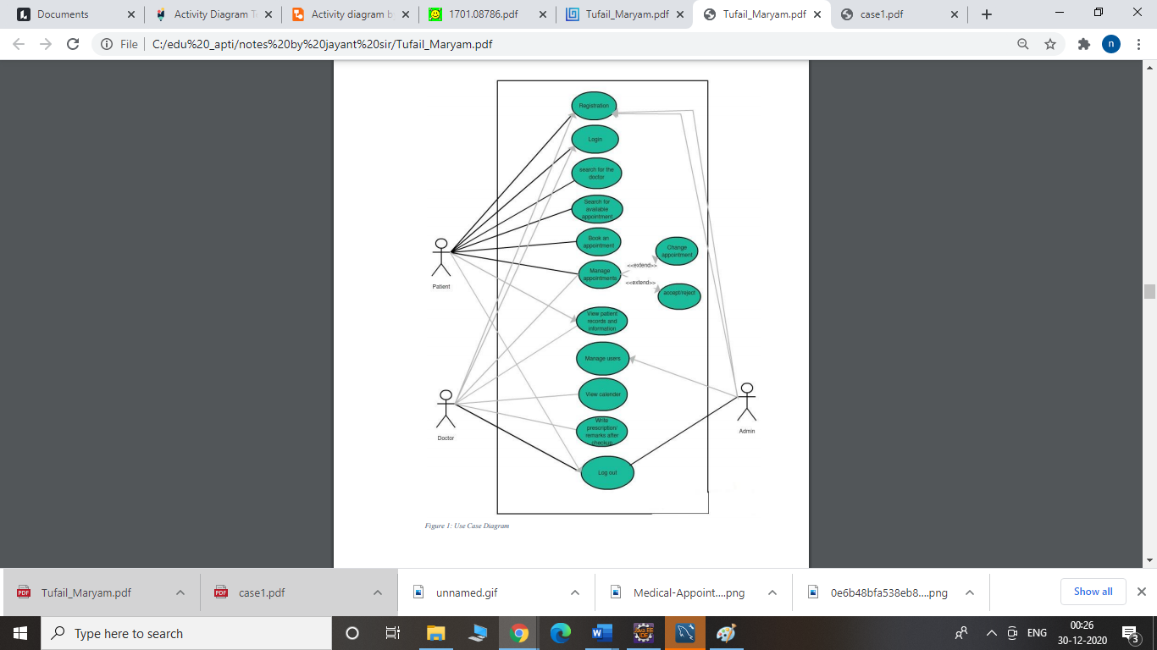

**5.3. ER DIAGRAM**

A basic ER model consists of objects called entities and specifies relationship among those entities. Purpose of this diagram is not to define any functionality rather show association and dependency among entities. ER diagram is drawn with "rectangular boxes" as entities and the "straight lines" showing the relationship between these boxes. An entity is an object or a thing that has an independent existence and can be easily differentiated from others. Each entity has some attributes like name, age, address, department etc. In the following diagram the doctor, patient, appointment, admin etc, all are different entities. So, an entity can be a person, animal, plant, event or a company. Entities consisting of similar attributes make the entity sets. These entities have some association among each other which make a relationship. These relationships can be "one to one" or "one to many" or "many to many". For example, a doctor and department can have "one to many" relationships, means one department can have many doctors but one doctor is related to only one department.

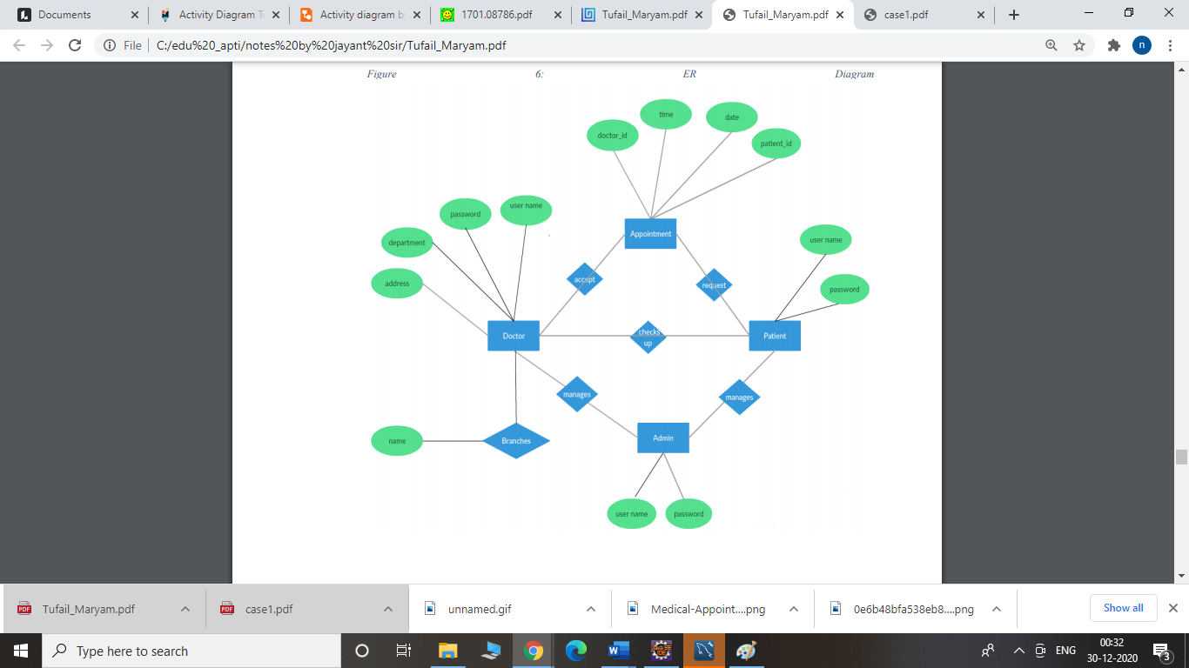

* 1. **DATA FLOW DIAGRAM**

1. The DFD is also called as bubble chart. It is a simple graphical formalism that can be used to represent a system in terms of input data to the system, various processing carried out on this data, and the output data is generated by this system.

The data ﬂow diagram (DFD) is one of the most important modeling tools. It is used to model the system components. These components are the system process, the data used by the process, an external entity that interacts with the system and the information ﬂows in the system.

DFDs how show the information moves through the system and how it is modiﬁed by a series of transformations. It is a graphical technique that depicts information ﬂow and the transformations that are applied as data moves from input to output.

DFD is also known as bubble chart. A DFD may be used to represent a system at any level of abstraction. DFD may be partitioned into levels that represent increasing information ﬂow and functional detail.



Figure 5.3.3.1: Level 0 Data Flow Diagram

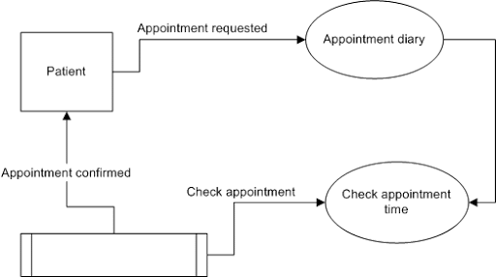

Figure 5.3.3.2: Level 1 Data Flow Diagram

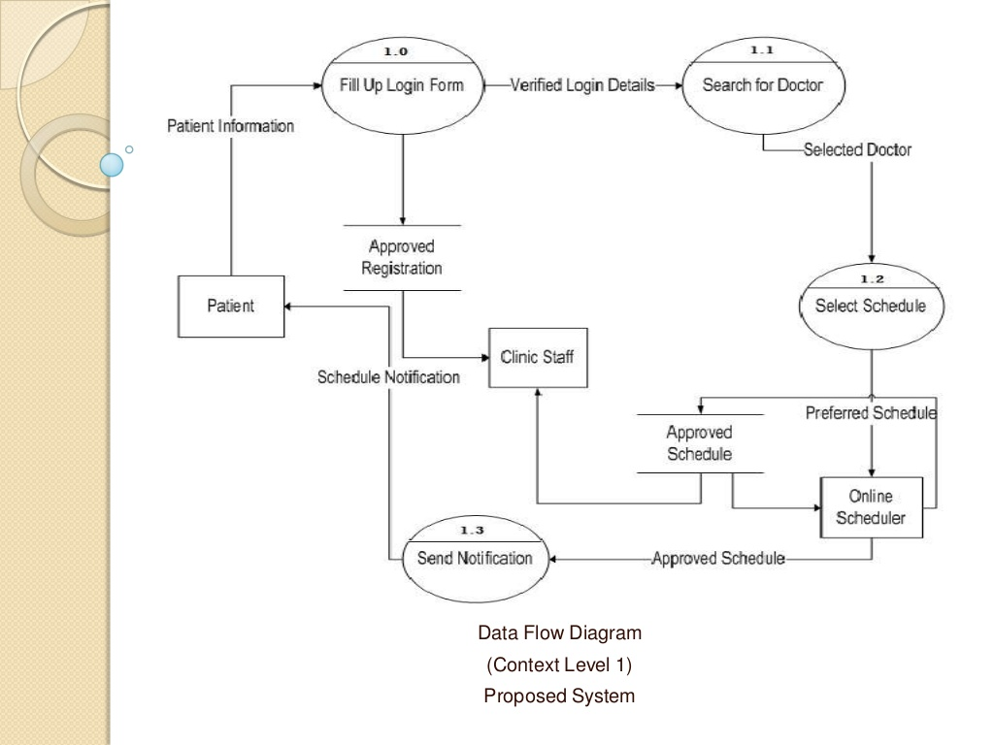

Figure 5.3.3.3: Level 2 Data Flow Diagram

**CHAPTER – 6**

**SYSTEM ANALYSIS**

**6.1 SYSTEM STUDY:**

* **FEASIBILITY STUDY:**

The feasibility study proposes one or more conceptual solution to the problem set of the

project. In fact, it is an evaluation of whether it is worthwhile to proceed with project or not.

1. Evaluation of feasibility of such solutions. Such evaluation often indicates shortcomings in the initial goals. This step is repeated as the goals are adjusted and the alternative solutions are evaluated. Feasibility analysis usually considers a number of project alternatives, one that is chosen as the most satisfactory solution. These alternatives also need to be evaluated in a broad way without committing too many resources.

2. To propose a set of solution that can realize the project goal. These solutions are

usually descriptions of what the new system should look like.

* **ECONOMIC FEASIBILITY**:

An evaluation of development cost weighed against the ultimate income of benefit derived from the development system of product. In economic

feasibility, cost benefit analysis is done in which expected cost and benefits are evaluated.

* **TECHNICAL FEASIBILITY:**

Technical Feasibility includes existing and new H/W and S/W requirements that are

required to operate the project using JSP. The basic S/W requirement is J2EE in which

the front end of the online hospital management project has been done. The basic entry

forms are developed in JSP and the data is stored in the MY SQL.

* **OPERATIONAL FEASIBILITY:**

Operational feasibility is mainly concerned with issues like whether the system will be

used if it is developed and implemented. Whether there will be resistance from users that

will affect the possible application benefits? The essential questions that help in testing

the technical feasibility of a system are following:

➢ Does management support the project?

➢ Are the users not happy with current business practices? Will it reduce the time

considerably? If yes, then they will welcome the change and the new system.

➢ Have the users involved in the planning and development of the project? Early

involvement reduced the probability of resistance towards the new system.

➢ Will the proposed system really benefit the organization? Does the overall response

increase? Will accessibility of information be lost? Will the system affect the

customers in considerable way?

* **LEGAL FEASIBILITY**:

A determination of any infringement, violation, or liability that could result from

development of the system. Legal feasibility tells that the software used in the project

should be original purchased from the legal authorities and they have the license to use it

or the software are pirated.

**Alternatives**:

An evaluation of alternative approaches to the development of system or product.

**6.2** **ADVANTAGES:**

* **Your Clients Want Convenience**

Having online appointment system is one step to making your customers satisfied with your services. New clients will want to book an appointment with you once they know that you have made your booking process easy. If they are impressed with their meeting with you, they will keep coming to you for treatment.

* **Patients Don’t Have to Wait Long Hours**

If your clients still need to come to your clinic to book an appointment to see you, then you need to start thinking of using the online appointment system as soon as possible. No patient wants to spend hours waiting to book an appointment when there are system online doctors out there who are offering equal service with a booking system that makes appointment scheduling quick and stress-free. Sick patients want to be attended to as quickly as they come into your clinic. Instead of making your patients wait hours for their turn to book an appointment, provide a scheduling system and save them the stress.

* **Reduces Patient No-Shows**

Patients can sometimes forget that they have a doctor’s appointment causing them to disappointment you on the scheduled date. With an online appointment system, however, there will be fewer disappointments as the system is designed to send reminders and confirmations to clients after they book an appointment. This way clients can look forward to their meeting with you and prepare well for it. Online scheduling system helps you to be organized and plan your activities around your meetings with your clients.

## Saves You and Your Employees Tons of Time

Now, however, you do not need your staff to ensure that bookings are done correctly. Your clients can go online and book appointments for themselves. For one thing, you can be confident that the correct information will be entered in the booking form since the patients will fill it themselves. Most importantly, it saves you and your staff time. The time that would have been used to answer phone calls or reply to emails of clients who want to book appointments can be used to accomplish other tasks, thus increasing productivity in the workplace.

## Allows Clients to Book at Any Time and Place

## With their mobile devices and the internet, patients can book an appointment from wherever they are and at any time. This is one of the major benefits of using the doctors online system. Agreed, many people may still use the telephonic appointment booking method, but these methods have a lot of challenges. Foremost among them is that the patient cannot call to make an appointment whenever they like. It must be within the hours that the phone lines are open. With the online booking system, however, you can book an appointment at any time and from any place.

**6.3 OUTCOME:**

* Time saving
* Monetary Savings:
* 24 hours convenience

**7.CONCLUSIONS**

This project has been a rewarding experience in more than one way. The entire project

work has enlightened us in the following areas.

a) We have gained an insight into the working of the HOSPITAL. This represents a

typical real world situation.

b) Our understanding of database design has been strengthened this is because in

order to generate the final reports of database designing has to be properly followed.

c) Scheduling a project and adhering to that schedule creates a strong sense of time

management.

d) Sense of teamwork has developed and confidence of handling real life project

has increased to a great extent.

e) Initially, there were problem with the validation but with discussions, we were

to implement validations.

**8.REFERENCES**

1. Alex Chaffee (2000-08-17). "What is a web application (or "webapp")?". Retrieved 2008-07-27.
2. Bailey, N. (1952). A study of queues and appointment systems in hospital outpatient departments, with special reference to waiting times. Journal of the Royal Statistical Society, A14, 185-199.
3. Bailey, N. (1954). Queuing for medical care. Applied Statistics 3, 137-145 . Designing appointment scheduling systems for ambulatory care services. Health Care Management Science 9, 47–58.
4. Cayirli, T, E. Veral, and H. Rosen. (2004). Assessment of patient classification in appointment systems. 1st Conference of the POMS College of Service Operations, New York, NY, USA.
5. Fernandes C, Daya M, Barry S, Palmer N (1994). Emergency department Patients who leave without seeing a Physician: The Toronto Hospital experience. Ann. Emer. Med., 24: 1092-1096.
6. Klassen, K. J., T. R. Rohleder. 2004. Outpatient appointment scheduling with urgent clients in a dynamic, multi-period environment. Internat. J. Service Indust. Management 15(2) 167–186.
7. Koole, G., and G. Kaandorp. 2006. Optimal outpatient appointment scheduling, Working Paper, Department of Mathematics, Vrije Universiteit Amsterdam, The Netherlands, http://www.math.vu.nl/˜koole/articles/hcms07b/ (checked on May 24, 2007).
8. James Duncan Davidson, Danny Coward (1999-12-17). Java Servlet Specification ("Specification") Version: 2.2 Final Release. Sun Microsystems. pp. 43–46. Retrieved 2008-07-27.

**SNAPSHOTS**

**HOME PAGE:**

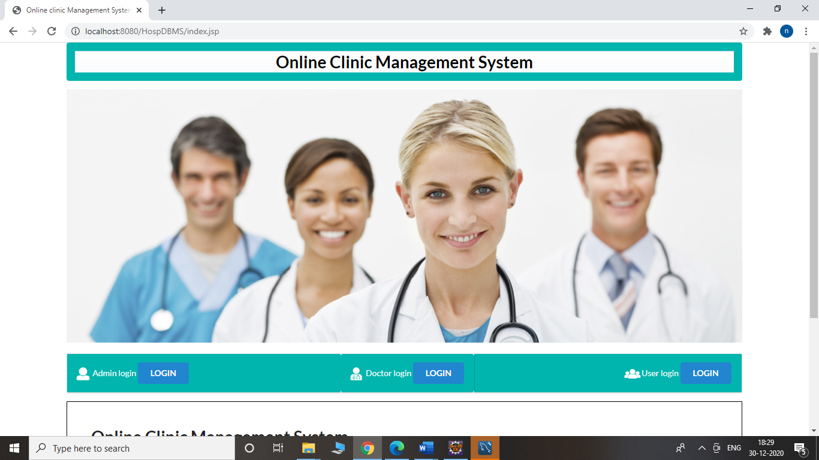

1. **Admin Login**

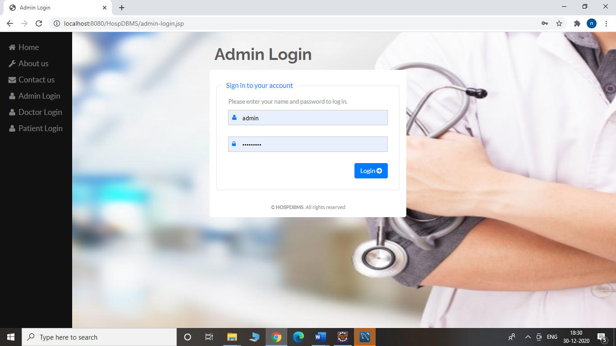



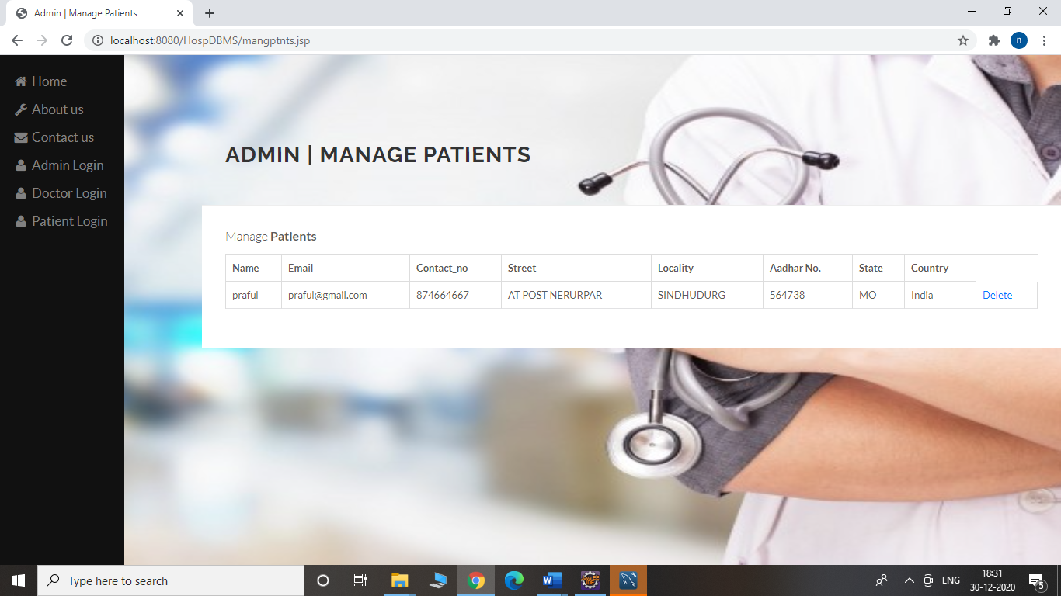

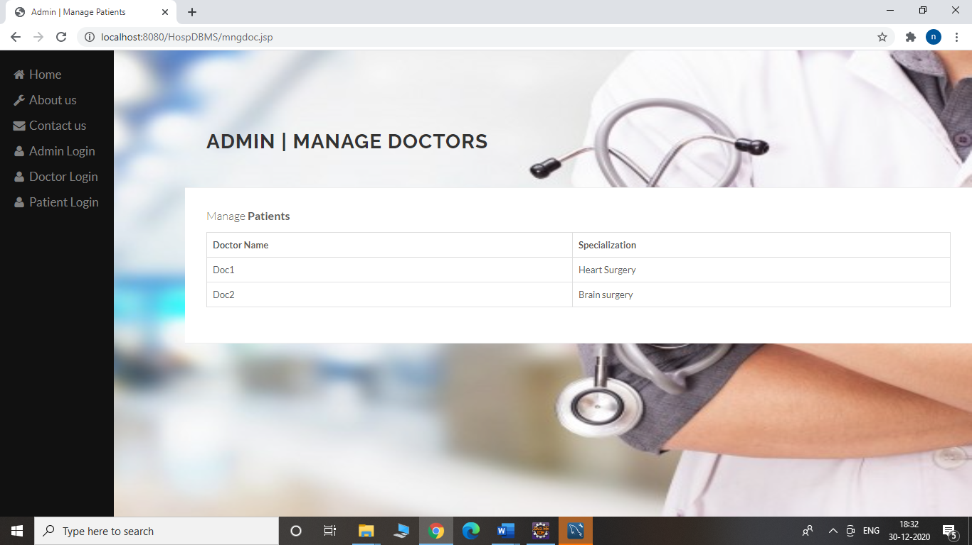

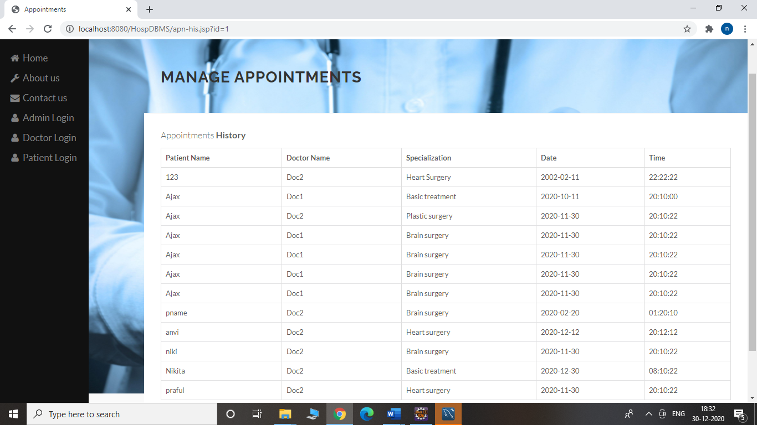

**2.Doctor Login**

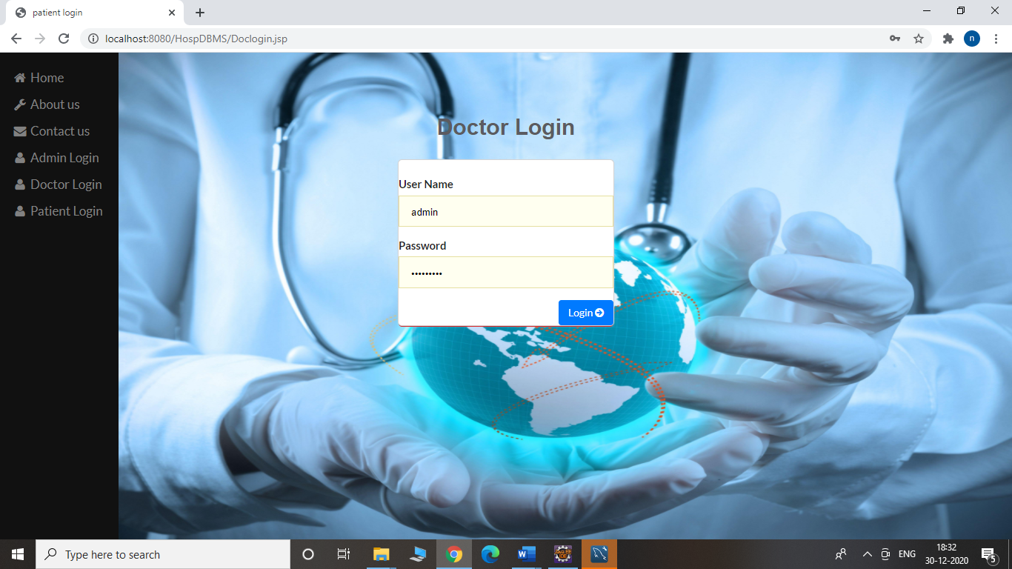

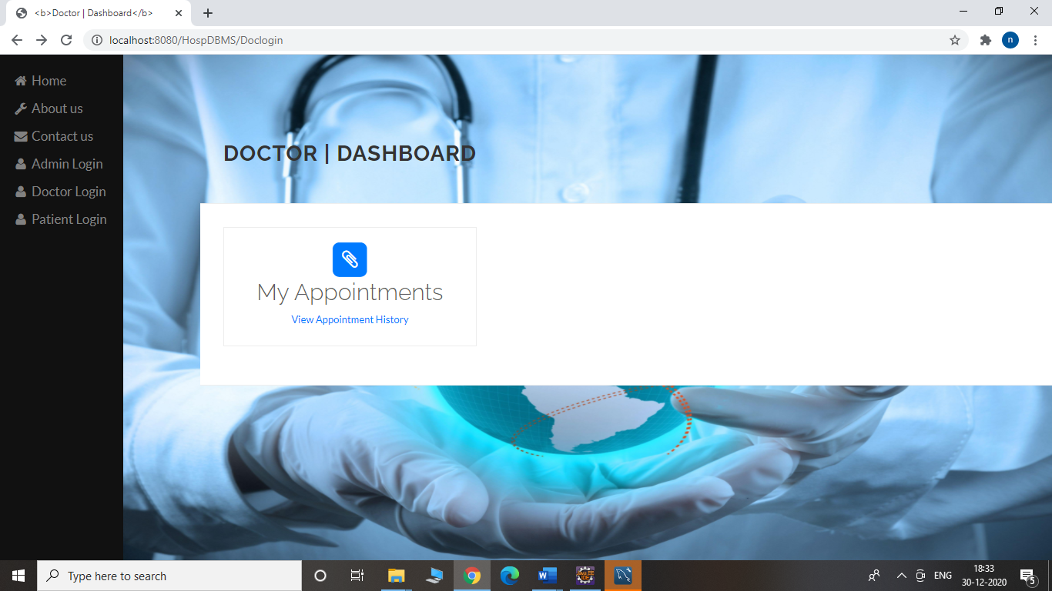

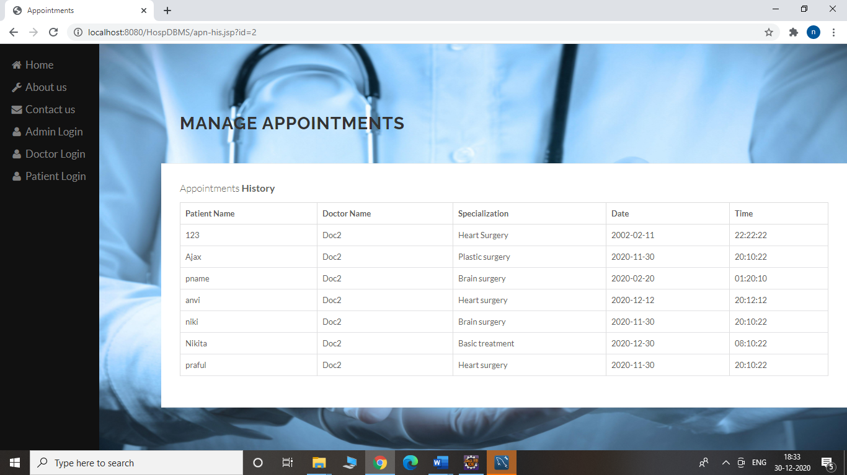

**3.Patient Login**

